January 24, 2023
Kawasaki Kisen Kaisha, Ltd.

Donation of Protective Equipment for Pasig River Cleaners in the Philippines

“K” Line Maritime Academy Philippines (KLMA), a primary training center for seafarers of Kawasaki Kisen Kaisha, Ltd. (“K” LINE), have decided to donate Personal Protective Equipment (PPE) such as boots, gloves, raincoats to the Pasig River Coordinating and Management Office (PRCMO) engaged in cleanup activities on the Pasig River in Manila.

On January 16th, handover ceremony was held by PRCMO. Capt. Baratang, president from KLMA, Mr. Prado, head of operation unit, Mr. Sibal, head of coordination unit, from PRCMO and many other staffs attended the ceremony.

PRCMO was established in January 2020 under the Department of Environment and Natural Resources (DENR) in Philippine to promote activities to maintain the cleanliness of the Pasig River and its tributaries through regular cleanup activities on the Pasig River, which is said to be one of the most polluted in the world. Our long-term environmental guideline, “K” LINE Environmental Vision 2050 (Note 1) calls for support and participation in social contribution activities for environmental conservation, and as our way of expressing our gratitude to the Philippine government and people for supplying competent seafarers working on “K” LINE operated vessels for more than 35 years. With all our hearts, we decided to donate this time. We will continue to support PRCMO to revive the clean Pasig River system and leave it as a legacy for future generations.

(Note 1) “K” LINE Environmental Vision 2050 :
https://www.kline.co.jp/en/csr/environment/management.html

【Handover Ceremony】
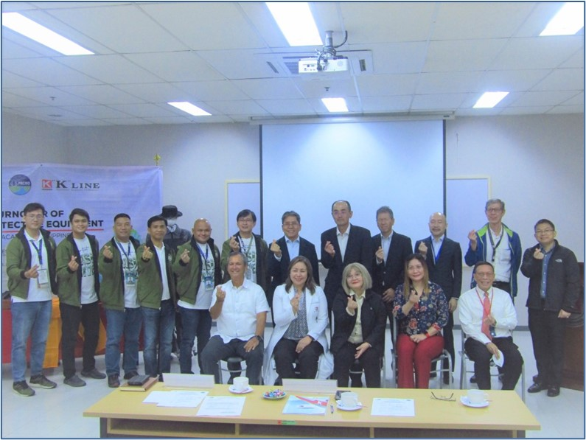
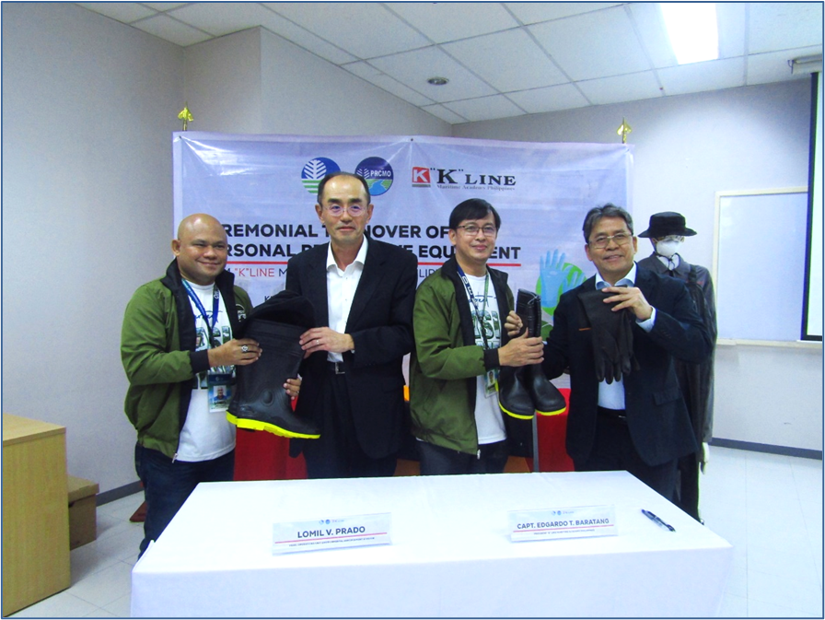
From Left:
PRCMO：Head of Operation Unit, Environmental Enforcement Division, Mr. Lomil V. Prado
“K” LINE：Representative, Chief Engineer, Hiroyuki Inui
PRCMO：Head of Coordination Unit, Mr. Garry S. Sibal
KLMA ：President, Captain Edgardo T. Baratang

For inquiries regarding this matter, please contact:

Hiroaki Uba
General Manager of Maritime Strategy Group
Kawasaki Kisen Kaisha, Ltd. (“K” LINE)
TEL: +81-3-3595-6169

Hajime Otsuda
Manager of Seafarers Policy Team, Maritime Strategy Group
Kawasaki Kisen Kaisha, Ltd. (“K” LINE)
TEL: +81-3-3595-5654

