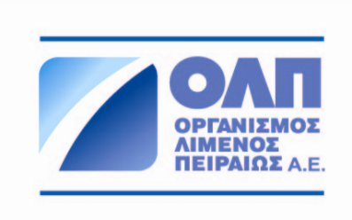


PRESS RELEASE
PPA S.A.: Green technologies and applications at the Port of Piraeus
Event for the presentation of the European Green C Ports Project in Athens
24 May 2022. On the occasion of the Green C Ports Project, PPA S.A. has organized a special hybrid event in collaboration with the ICCS of NTUA, the Municipality of Piraeus, and the companies Glomar and ZEN Travel. At the event, held in Athens Marriott, the first project results were presented concerning the specifications and the installation of the environmental sensor network as well as the implementation of the pilot IT platform at the participant ports.
The event was attended by Cpt. Weng Lin, DCEO of Port of Piraeus, Dr. Evangelos Kyriazopoulos, Secretary General of Ports, Port Policy & Maritime Investments - Ministry of Maritime Affairs and Insular Policy, Mrs. Antonia Karakatcani, Deputy Mayor οf the Directorate οf Environment and Landscape, Piraeus Municipality, Stefano Campagnolo, Project at CINEA, European Commission.
It is noted that the Green C Ports Project involves the installation of a sensor network measuring environmental and meteorological data (temperature, atmosphere pressure, humidity, air quality, noise, vessel emissions), alongside the implementation of a technological platform for environmental footprint monitoring with real time notifications. The project is implemented in 6 European ports including the Port of Piraeus, while it is considered to be a pioneer in the application of green technologies and applications in European ports. The range of digititalization technologies and tools developed create a new operational framework for ports and can become a reference point to other ports internationally.
In the second part of the event, the project partners presented in detail the pilot actions of the project concerning the installation of sound and air pollution sensors and of data management platforms at participant ports aiming at predicting and notifying noise levels and air quality as well as CO2 emissions at the Port of Piraeus and Valencia. Also, reduction of port traffic and CO2 emissions at the port of Valencia and vessel optimization calls due to bad meteorological conditions at the port of Venice, etc.
The implementation of the Green C Ports project is another key PPA initiative, in the context of the company’s broader holistic corporate strategy framework towards environmental protection and dealing effectively with climate change impacts, through systematic and truly targeted actions to help further driving the development forward and act as a role model in top environmental matters.

Piraeus Port Authority SA is a Greece-based company engaged in the management and operation of Piraeus port, Greece largest post. The main activities of Piraeus Port Authority SA are ships’ anchoring services, handling cargo, loading and unloading services as well as goods storage and car transportation. The Company is also responsible for the maintenance of port facilities, the supply of port services (water, electric current and telephone connection, among others), for services provided to travelers and for renting space to third parties. The main shareholder of Piraeus Port Authority SA is COSCO SHIPPING with a stake of 67 percent, one of the world's largest maritime operators.

