January 4, 2022

Kawasaki Kisen Kaisha, Ltd.

2022 New Year Message from the President

“Boldly and deliberately entering a new phase in a year we will take a stride toward the future”

*The New Year Message delivered by Yukikazu Myochin, President & CEO at “K” LINE*

*Tokyo Head Office on January 4 is posted below.*

To everyone throughout the entire “K” LINE Group, I extend my very sincerest Happy New Year wishes.

**The environment surrounding “K” LINE**

The global economy is generally continuing to recover from the impact of COVID-19. Although the future spread of COVID-19 and timing of the end of pandemic remain uncertain, the progress of vaccinations and the economic stimulus measures such as financial support from national governments will contribute to continuing to maintain the trend of recovery, and I expect there will be a further shift from recovery supported by policy effects to autonomous recovery in the global economy from 2022. Meanwhile, causes for concern include a resurgence in the spread of COVID-19 due to the emergence of variant strains and changes in trade structure resulting from geopolitical factors such as the conflict between the United States and China. As we enter the era of living with COVID-19, we must carefully monitor the effects on the real economy.

**Looking back on 2021**

Looking back on the performance of “K” LINE, we achieved the highest earnings on record in the first half of fiscal 2021. The contribution of Ocean Network Express (ONE), an equity-method affiliate, was significant, but the company’s own business also improved significantly. Recoveries in dry bulk and product logistics segments other than containerships, such as car carrier and the logistics business, with performance significantly affected due to the decline in transportation demand caused by the spread of COVID-19 are also driving improvements this fiscal year. Last fiscal year, we decided on a policy to optimize our fleet by reducing approximately 50 uneconomic and aged vessels mainly made up of dry bulk and car carriers. Of these, the car carriers were completed in the first half of the current fiscal year, and optimization of the dry bulk fleet is being brought forward to within the current fiscal year, which is expected to have the effect of further improving revenue from next fiscal year.

The energy resources transportation business struggled due to the continued slump in offshore support vessel business but continued to contribute to stable revenue based on medium to long-term charter contracts such as those for LNG tankers, vessels carrying coal for power generation, VLCCs and LPG vessels. In light of the future economy of the European offshore support vessel business, we have recently decided to restructure by withdrawing from the business.

Due to performance improvements in the containership business and within the company’s own four business divisions, we have been able to set a course for recovery during the current fiscal year by rationalizing the fleet, restructuring unprofitable business and working to address the Company’s negative legacy.

**Policy and issues for 2022 (Revision of the management plan)**

The Company is entering into new phase with the improvement of performance. Under the current management plan, we planned to have capital of 400 billion yen by fiscal 2030, but thus reached 469.6 billion yen as of September 30, 2021, and the equity ratio was restored to 40%. As a result of implementing several structural reforms in the past, we were able to considerably repair damaged equity, and by implementing the remaining fleet rationalization and restructuring of unprofitable businesses in the current fiscal year, we must continue to move forward with focus on growth by restoring the competitiveness of the company’s own business. In the future creation project launched last July, we have been proceeding with consideration aimed at enhancement of corporate value. In the new business plan, we need to determine where to inject management resources to further strengthen “K” Line, and how the company will provide added value to reduce environmental impact and improve transportation quality, such as environmentally friendly vessels.

Pursuing the strengthening of existing business and growth strategy at the same time is not easy, but I would like to maintain the continued expansion of our financial base and securing stable revenue and proceed with new initiatives while assessing risks that can be balanced with returns. By positively viewing this situation as an opportunity, I would like to draw up a new management plan incorporating growth strategy and disciplined investment, and work with everyone to come up with ways to make further strides forward for enhancing coporate value

Needless to say, safe and secure services of high quality are the core of “K” LINE’s services. Even while faced with the COVID-19 pandemic, I would like all officers and employees to work as marine transportation professionals to ensure we continue to be chosen by customers by thoroughly implementing the strengths of “K” LINE serving an important part of the supply chain.

**Environmental action**

Sustainability initiatives and particularly environmental action need to be perceived as growth opportunities and further focused upon. Many customers are already aiming to reduce greenhouse gas emissions throughout the entire life cycle of products and are also considering rebuilding the value chain. In order to realize greenhouse gas reductions not only in the manufacturing process, but also in the transportation process for materials, parts and finished goods, we must offer optimal solutions with higher added value to customers. Changes in energy structure aimed at the realization of carbon neutrality also provide medium- to long-term opportunities. As demand for the transportation of materials required for the development of renewable energy such as offshore support for offshore wind energy generation, for the transportation of new forms of energy such as hydrogen, ammonia, and for the transportation of liquefied CO2 are expected to expand, the provision of services for supply chain creation and transportation present us with substantial growth opportunities.

In November last year, we partially revised the “K” LINE Environmental Vision 2050, our long-term policy on environmental measures, replacing the goal of halving emissions by 2050, which was the same as the goal of IMO, with the new goal of the “Taking on the Challenge of Achieving Net-Zero GHG emissions” by 2050. As specific measures, we have already decided to build eight new LNG-fueled car carriers in addition to one that has already been completed, and also order one LNG-fueled capesize bulk carrier and one LPG-fueled LPG carrier. We also aim to introduce zero-emission vessels as early as possible by the end of the second half of the 2020s. The GHG Reduction Strategy Committee will further accelerate projects for both next-generation alternative fuels and safe environmental support technology.

As digitalization accelerates and values change, “K” LINE will proceed to not only improve the efficiency of land operations, but also implement initiatives to reduce the workload of seaborne employees and support safe operations. We will utilize digital technology such as the development of the recently announced engine plant operational support system utilizing AI and lookout and ship handling support system, in addition to the improvement of vessel data analysis technology leveraging AI technology in order to refine the Company’s core values of safety, environment and quality, and promote digital transformation (DX).

Finally, everyone in the “K” LINE Group has worked to balance everyday operations with measures to prevent infection as we have been forced to endure a variety of restrictions and limitations on our lives not only in Japan, but also overseas. Seaborne employees have also engaged in safe operation based on the strong resolve not to stop vessels for even a day despite the great difficulties faced when embarking and disembarking. Again, I would like to extend my deepest gratitude.

I wish all of you and your families good health and prosperity as we celebrate the New Year and pray that all our ships will navigate safely throughout 2022 and it is a year of new progress for the members of the entire “K” LINE Group.

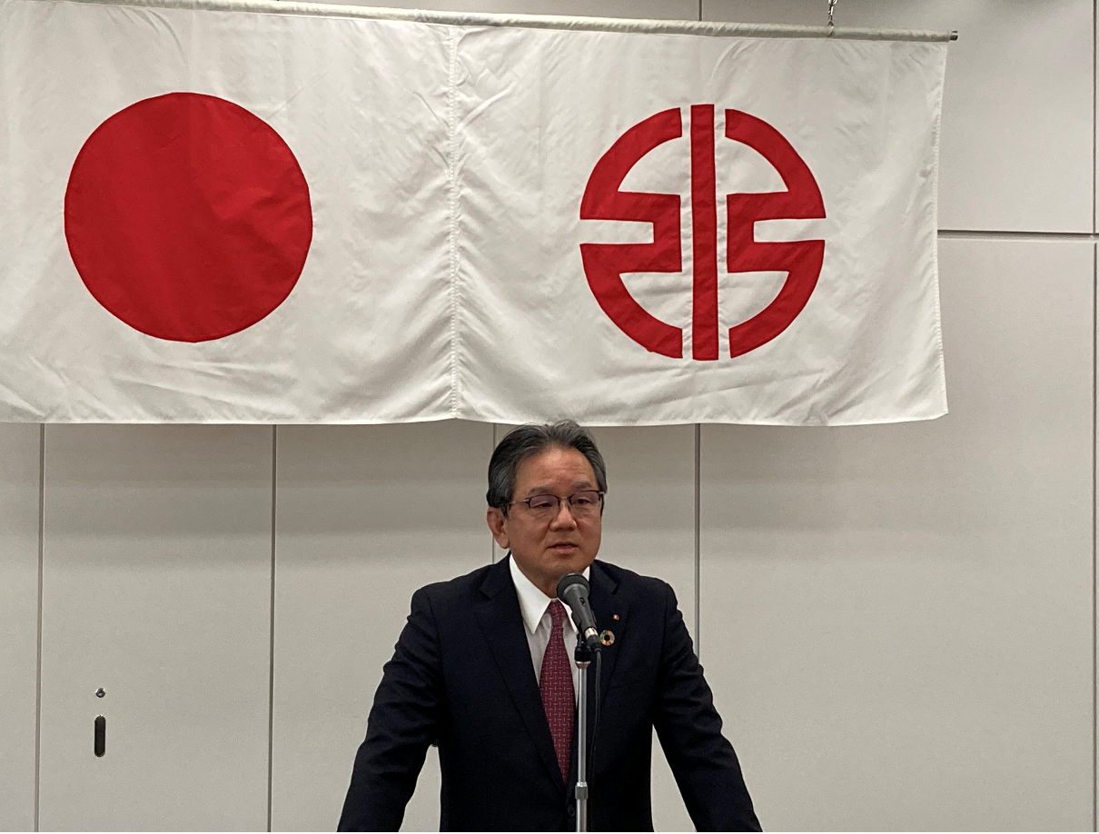

For further information, please contact:

Kawasaki Kisen Kaisha, Ltd. (“K” LINE)

Goro Kitamura

General Manager

Corporate Sustainability, IR & Communication Group

Phone: +81-3-3595-5189