July 7, 2020

Kawasaki Kisen Kaisha, Ltd

**“K” Line formulated the revised edition of “K” Line Environmental Vision 2050**

**- Blue Seas for the Future -**

Kawasaki Kisen Kaisha, Ltd. (“K” Line) has thoroughly revised the long-term guideline concerning environment, “K” Line Environmental Vision 2050 - Blue Seas for the Future -, in order to strengthen the initiatives toward global environmental preservation such as reduction of GHG(Greenhouse Gas).

Since “K” Line formulated “K” Line Environmental Vision 2050 in 2015, which set forth our long-term goals for 2050 as a frontrunner, we have engaged in reduction of environmental load, research and introduction of advanced technology by using this vision as a guideline. While we achieved most of the 2019 interim milestones including CO2 reduction and introduction of environmental flagship set in this vision, we saw dramatic changes in environment and its requirement from society/stakeholder how to deal with environmental preservation.

Therefore, we came to a decision to revise the vision this time．

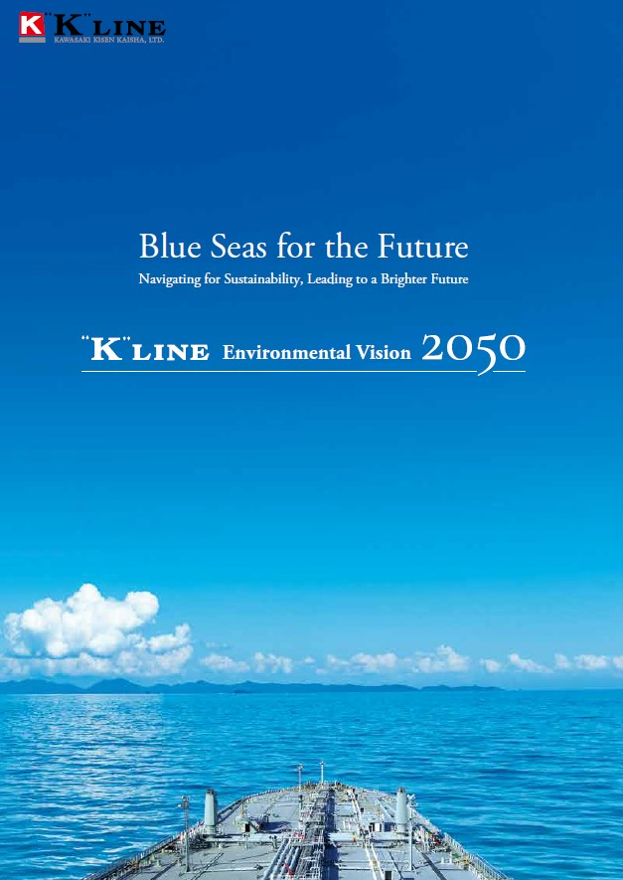Revised edition is based on the results of scenario analysis, recommended by TCFD, Task Force on Climate-related Financial Disclosures and rearranged the targets into two main factors, “Decarbonization” and ”Aim for zero environmental impact”, and set the new milestone goals for 2030.

Especially on “Decarbonization”, as 2030 interim milestones, “K” Line is aiming the improvement of CO2 emission efficiency by 50% compared with 2008, which surpasses the 2030 target set by IMO, International Maritime Organization, “improvement of CO2 emission efficiency by 40% over 2008”. “K” Line will continue to research and develop best solution including new technologies toward goal for GHG zero emission.

As an environmental front runner, we will continue to aim at providing more environmentally low-loaded and highly efficient services for more people throughout the world.

